ASSIGNMENT -1

Q1) Create the database loans.



Q2)USE THE DATABASE LOANS.



Q3) create the table_ACCOUNTS and insert tuples in it.



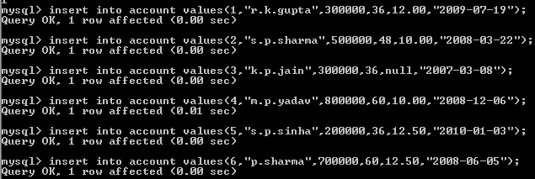

Q4) display the details of account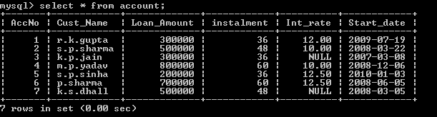

Q5) Display the accno,cust_name,andloan_amount of all the loans.

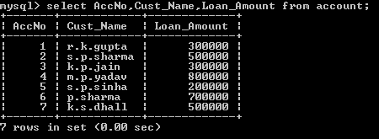

Q6) Display the details of all the loans with less than 40 installment.

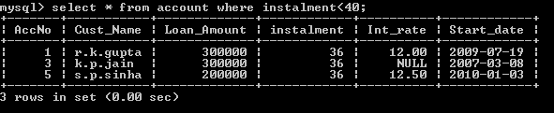

Q7) Display the accno and loan amount of all the loans started before 01-04-2009

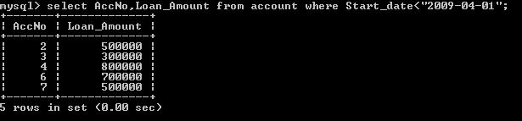

Q8) Display the Int_rate of all the loans started after 01-04-2009.

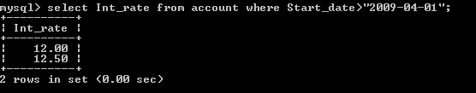

Q9) Display the details of the loans whose rate of interest is null.

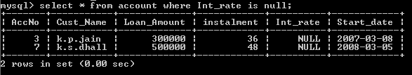

Q10)Display the details of all the loans whose rate of interest is not null.

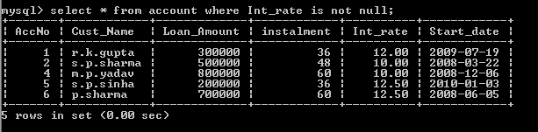

Q11)Display the number of installment of various loans from the table account. A loan should be appear only once.

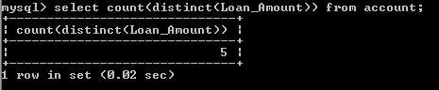

Q12) Display the number of installment of various loans from the table account. An installment should be appear only once

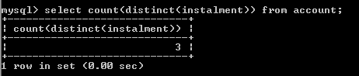

Q13)Display the details of all the loans started after

31-12-2008 for which number of installment are more than 36.



Q14)Display the cust_name and loan_amount for all the loans which donot have number of installment 36

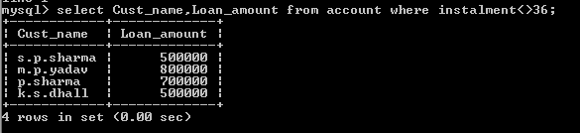

Q15)Display the cust_name and loan_amount of all the loans for which the loan amount is less than 500000 or int_rate is more than 12

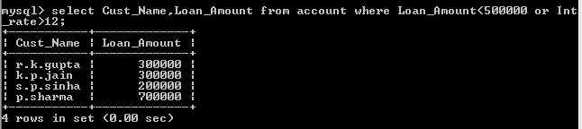

Q16)Display the details of loans which started in the year 2009.

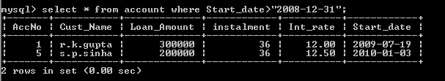

Q17)Display the details of all the loans whose loan_amount is in the range 400000 to 500000



Q18)Display the details of all the loans whose int_rate is in the range 11% to 12%



Q19)Display the cust_name and loan_amount of all the loans for which the number of installments are 24,36,48

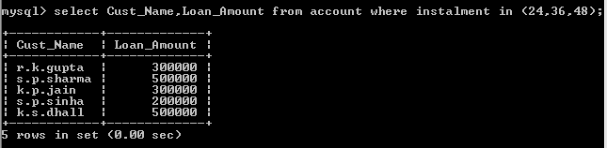

Q20)Display the details of all the loans whose loan_amount is in the range 400000 to 500000

(using between operator)

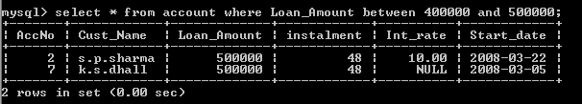

Q21))Display the details of all the loans whose int_rate is in the range 11% to 12%.(using between operator)

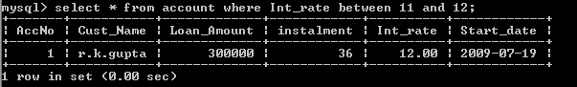

Q22)Display the accno,cust_name,andloan_amount of all the loans for which cust_name ends with “Sharma”

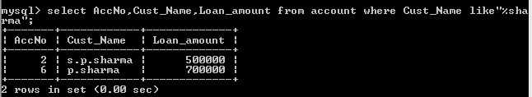

Q23)Display the accno,cust_name,andloan_amount of all the loans for which cust_name ends with “a”

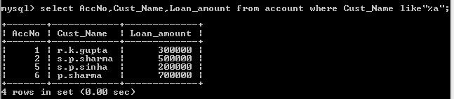

Q24)Display the accno,cust_name,andloan_amount of all the loans for which cust_namecontain with “a”

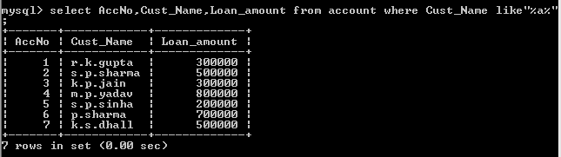

Q25)Display the accno,cust_name,andloan_amount of all the loans for which cust_name does not contain with “p”.

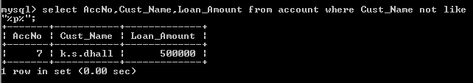

Q26) Display the accno,cust_name,andloan_amount of all the loans for which cust_name contains a as the second last character.

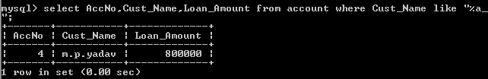

Q27)Display the details of all the loans in ascending order of their loan amount.

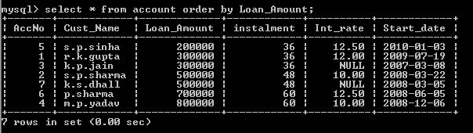

Q28) Display the details of all the loans in descending order of their start date.

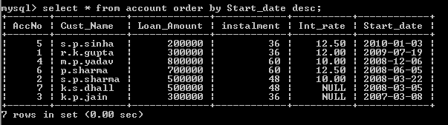

Q29) Display the details of all the loans in ascending order of their loan amount and within loan amount in the descending order of the start date.

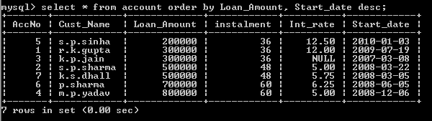

Q30) Put the intrest rate 11.5% for all the loans for which intrest rate is null.



Q31) Increase intrest rate by 0.5% for all the loans for which the loan amount is more the 400000.



Q32) For each loan replace intrest (loan amount*int rate *installment)12*100

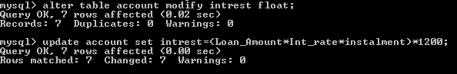

Q33) Delete the record of all the loans who start date is before 2007.



Q34) delete the record of all the loans of k.p. jain



Q35)Add another column category of type CHAR(1) in the loan table



Q36)Display the sum of loan amount whose int rate is greater than 10.

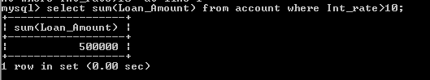

Q37)Display the max. interest from loan table.

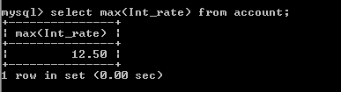

Q38)Display the count of all loan holder whose name ends with Sharma.

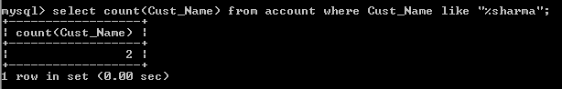

Q39)Display the count of all loan holder whose int.rate is null

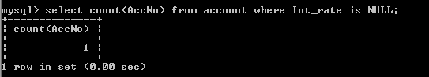

Q40)Display the interest wise detail of loan account holder.

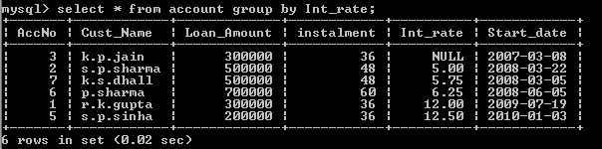

Q41)Display the interest wise detail of loan account with atleast 10 installment remaining

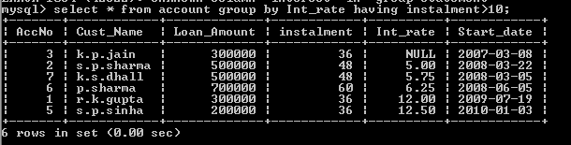

ASSIGNMENT-2

Q)Consider the following table homework and write answers for below given questions:

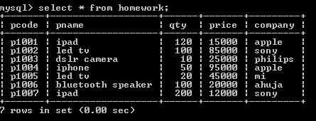

1)selectlcase(pname) from products where pname=’LED TV’;

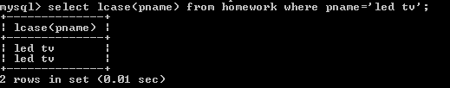

2) selectsqrt(price) from products where price>5000;

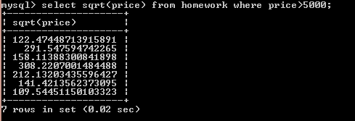

3) select mod(qty,3) from homework;

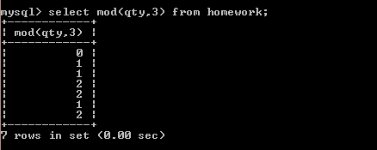

4) select substr(company,1,4) from homework;

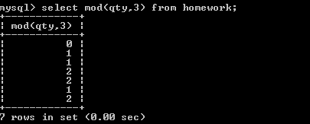

5) select concat(concat(pname,”-“),qty)from homework where company=’Apple’;

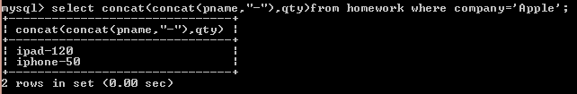

6) selectpname,truncate(mod(price,103)) from homework where qty>100;

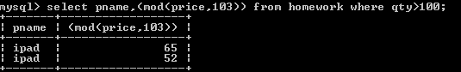

7)selectpcode,round(qty) from homework wehere company in(“sony”,”mi”);

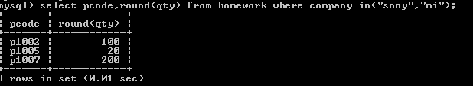

8)select right(pname,4) from homework where qty=10 or qty=20;

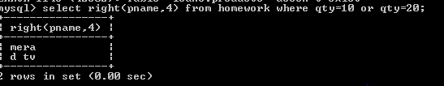

9) select substr(pname,2,3) ,left(pname,3), right(pname,3) from homework;

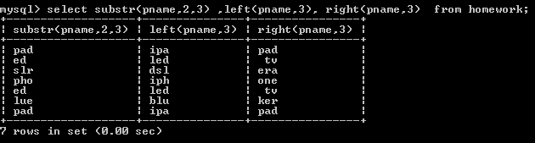

10)select count(*),max(price),min(price) from homework group by pname;

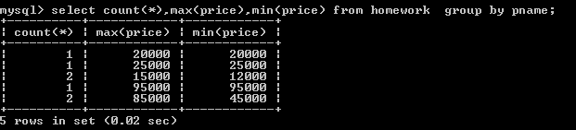

11)selectavg(price),sum(price),count(*) fromhomework group by company;

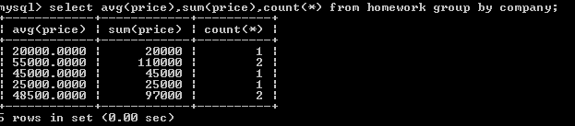

12)select count(*),sum(price) from homework group by company having company=”sony”;

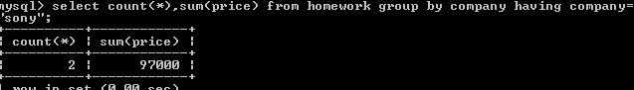

13)select now(),curdate(),sysdate();

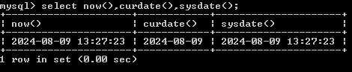

14)select year(“2024/04/20”), month(“2024/04/20”) ,day(“2024/04/20”);

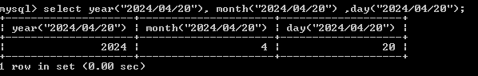

15)selectdayofyear(“2024/04/20”), dayname(“2024/04/20”) ,dayofweek(“2024/04/20”);

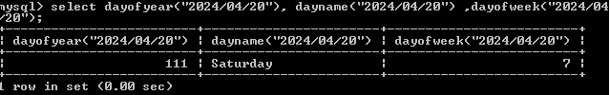

ASSIGNMENT 3

Q) Consider the following table named GYM with details about fitness products being sold in the store.

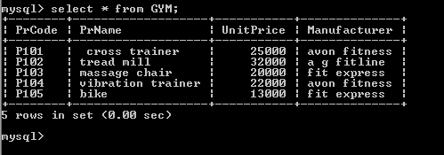

1. Display the names of all the products in the store.

Ans) 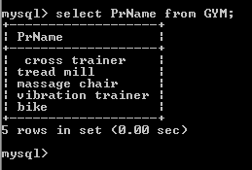

1. Display the names of all the products with unit price less than Rs.20000.

Ans) 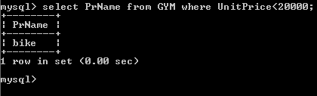

1. Display the details of all the products with unitprice in range 20000 to 30000.

Ans) 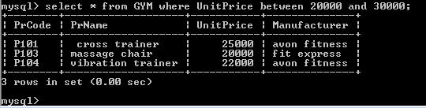

1. Display the names of all the products by the manufacturer “avon fitness” in descending order of unit price.

Ans) 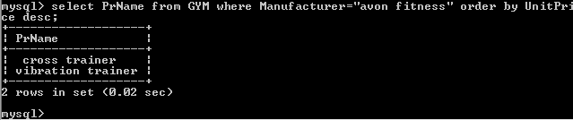

1. Change the unit price data of all the rows by applying a 10% increased on all the products.

Ans) 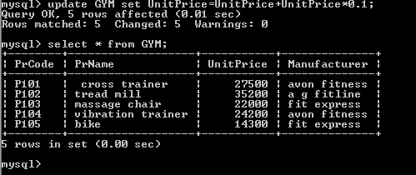

1. Remove all the products rows manufactured by avon fitness.

Ans) 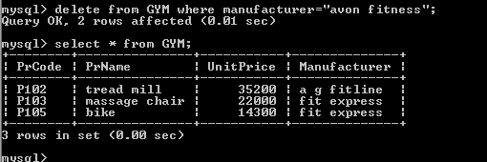

1. Display the details of all the products with manufacturer name starting with A.

Ans) 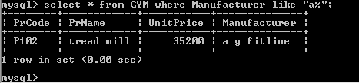

PYTHON QUESTIONS

1)Write a program to create a listA a containg positive and negative from the console.Also create two separate list called PosNum and NegNum to store positive and negative numbers respectively.Also, Calculate and print the total of all positive and negative numbers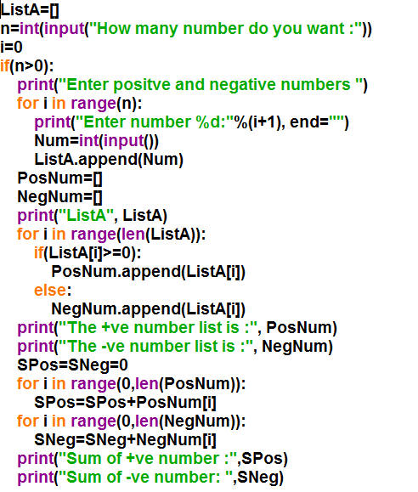

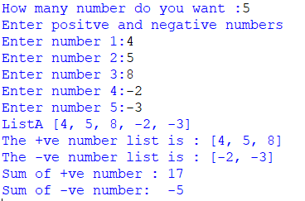

2)Write a program to shift the first element to the last position.

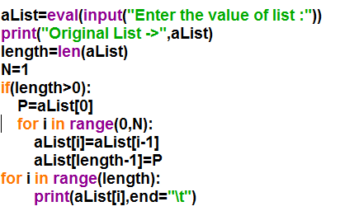



Q3. Given an array named AList with the following elements

[2, 3, 4, -5, 6, -8, 11, -9]

Write a python program to shift the negative to left and the positive numbers to right so that the resultant list will look like :

[-5, -8, -9, 2, 3, 4, 6, 11]

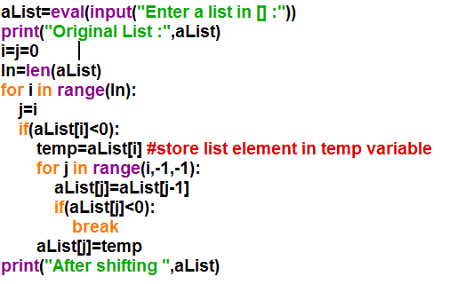

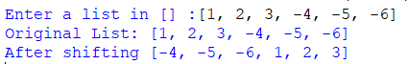

Q4. Write a menu driven program to perform the following operations on a list/array.

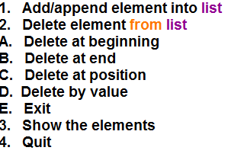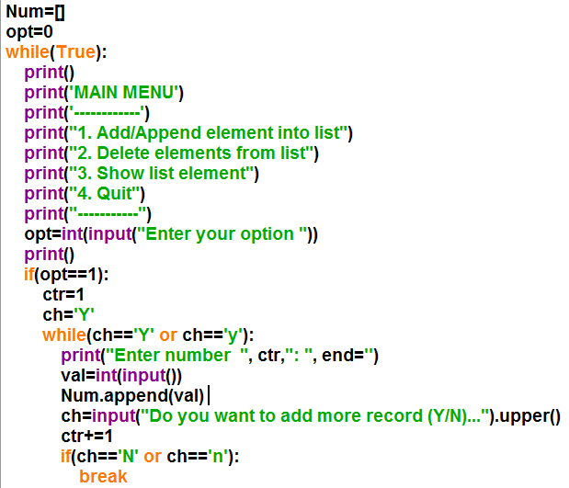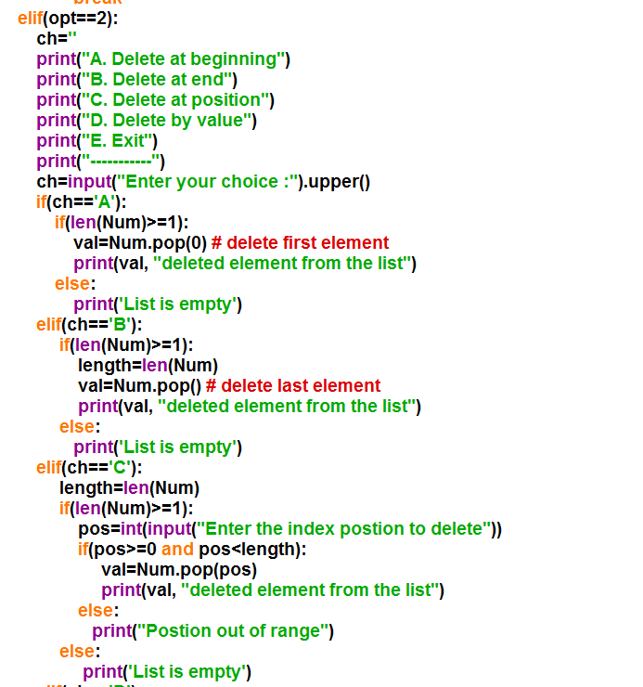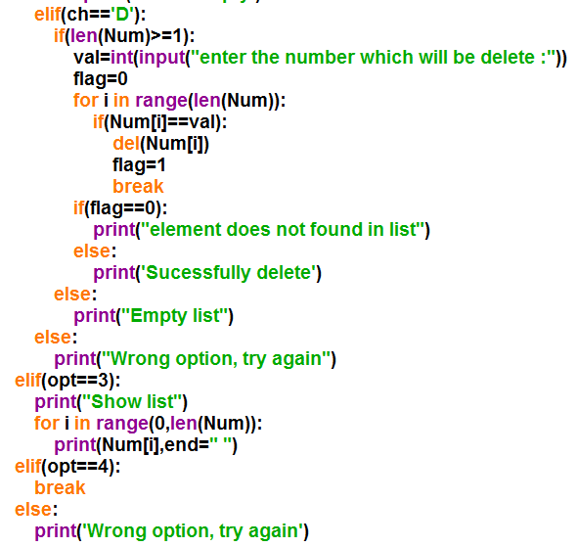

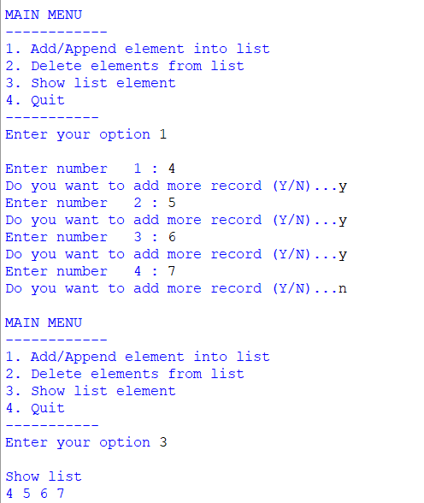

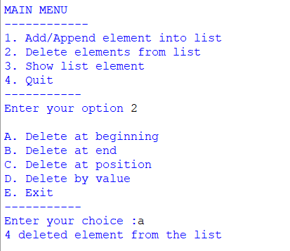

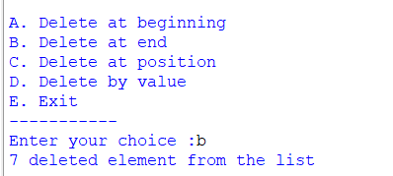

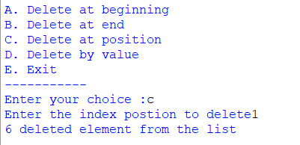

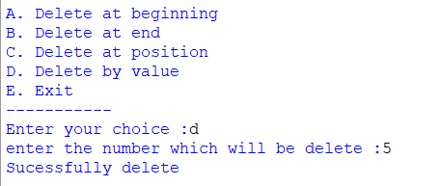

Q5)WRITE A PROGRAM TO CALCULATE SIMPLE INTEREST WITH AND WITHOUT USING FUNCTION.

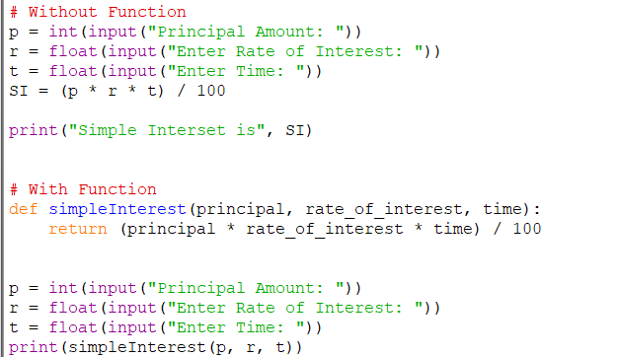

WITHOUT FUNCTION:

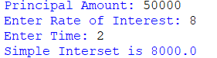

WITH FUNCTION:

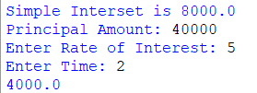

Q6) WRITE A MENU DRIVEN PROGRAM TO CREATE PATTERN

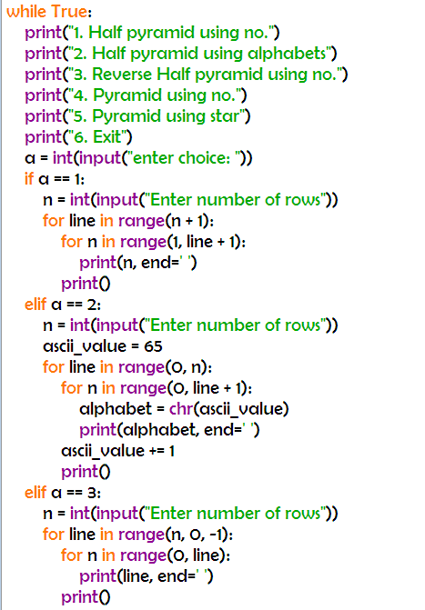

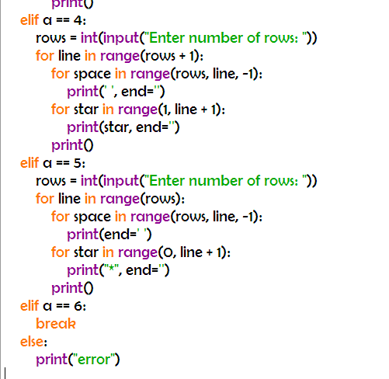

OUTPUT:

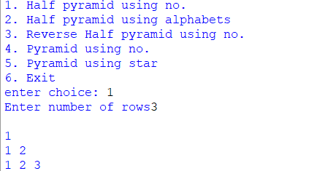

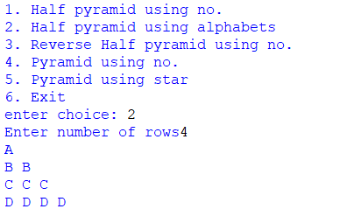

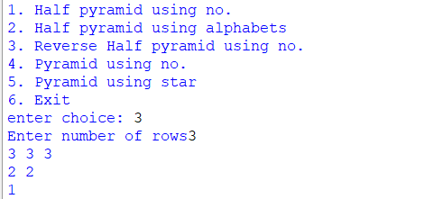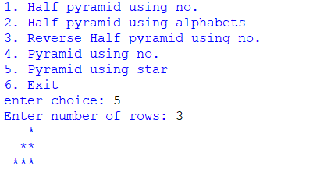

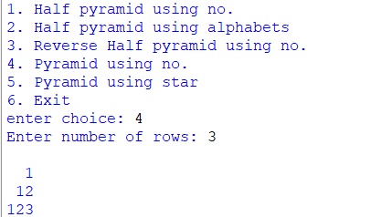

Q7) - Write a Program to Create Menu Driven for a Number

a)Palindrome

b)Armstrong

c) Reverse a Number

d) Square of Each Digit

e)Product of Each Digit

f) Exit

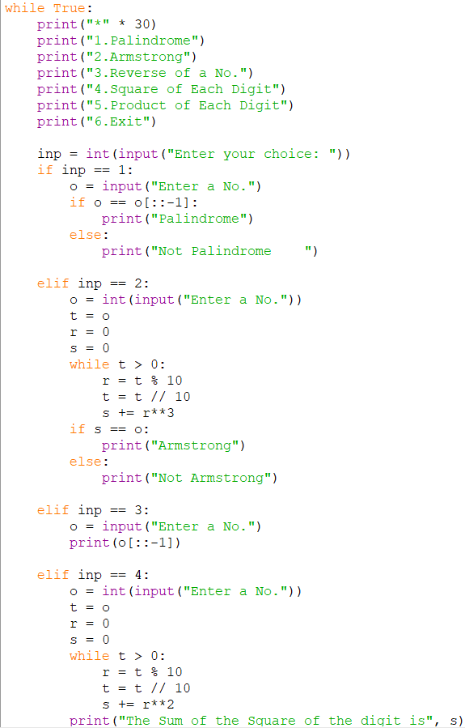

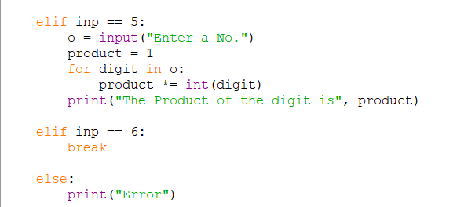

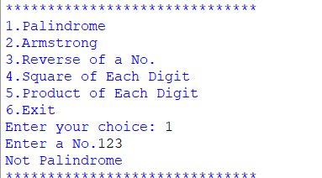

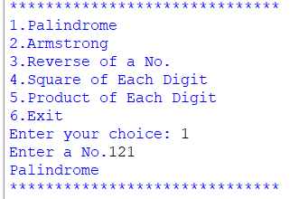

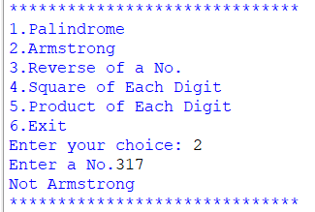

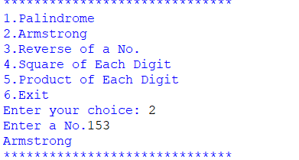

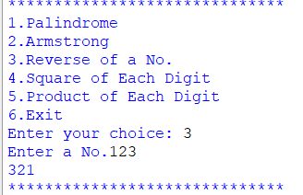

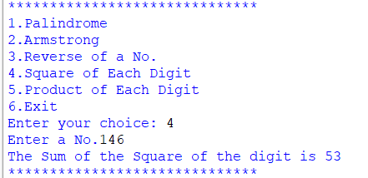

Q8) Practical 7 - Write a Python to accept a string in a mixed case. Pass the string to a function def Freq (String). The function should find and the frequency of each vowel.

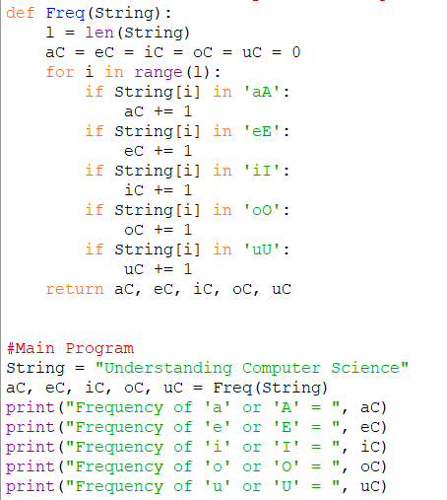

Output :-

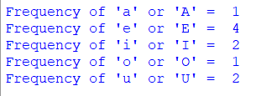

Q9) Write a Python code to accept ten different temperatures in Celsius in a list. Pass each temperature to a function which returns the temperature converted into Fahrenheit. Display only those temperatures, which are more than the normal body temperature, i.e. 98.6 F .

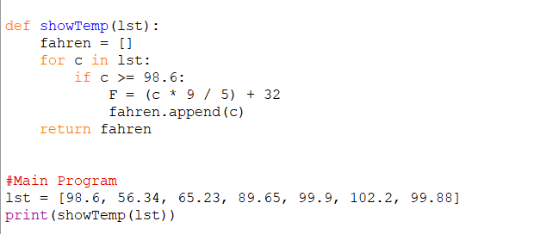

Output :



Q10) Write a Python code to accept a string from the user. Pass the string to a function def Display(str) which displays the constants present in the string.

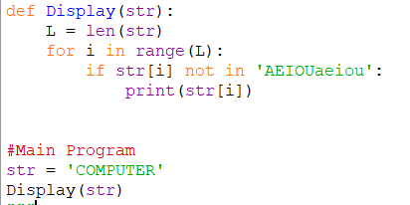

Output:

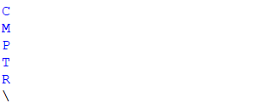

DATA FILE HANDLING

Q)WRITE A FUNCTION TO COUNT ME/MY IN PYTHON PRESENT IN A FILE.

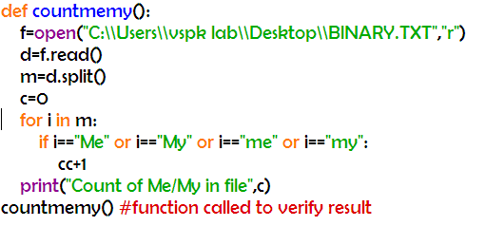





Q2)WRITE A FUNCTION TO COUNT A OR M IN THE FILE.

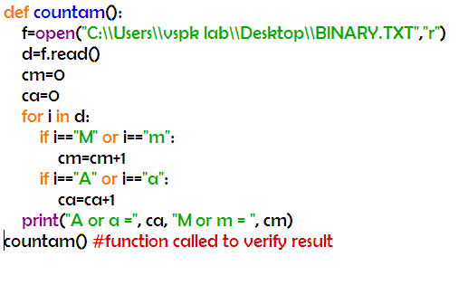



Q3) Write a function in python to count the number of lines in a text file starting from “A”

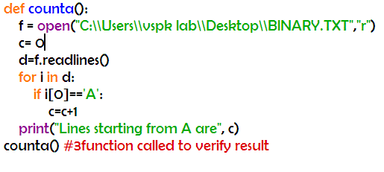



Q4 ). Write a function RevText() to read a text file " " and Print only word starting with 'I' in reverse order

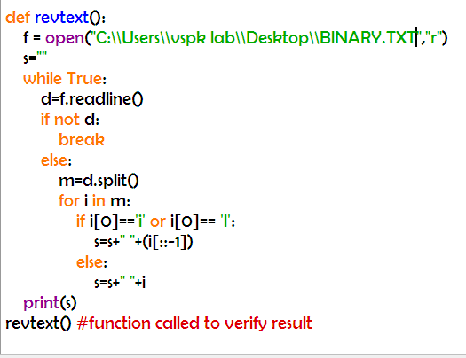 

Q5)Write a method/function DISPLAYWORDS() in python to read lines from a text file, and display those words, which are less than 4 characters.

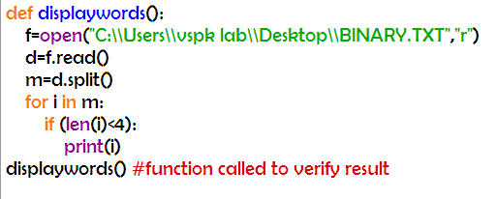

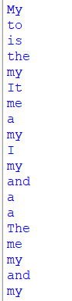

Q6. Write a function in python to count the number of lowercase alphabets present in a text file .

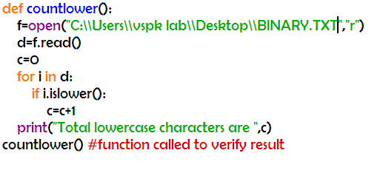



Q7. Write a user-defined function named count() that will read the contents of text file named and count the number of lines which starts with either "I" or "M".

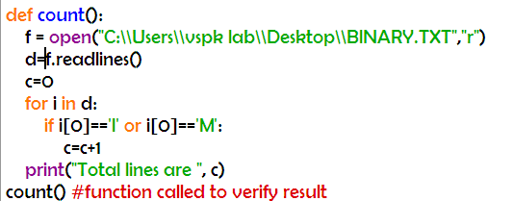



Q8. Write a function countmy() in Python to read the text file and count the number of times "my" or "My" occurs in the file.

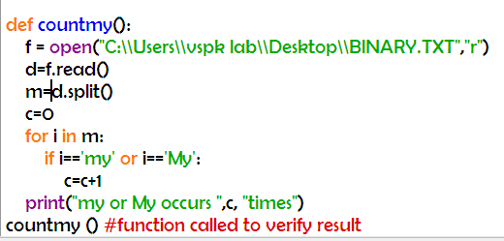



Q9. Write a user defined function countwords() in python to count how many words are present in a text file named.

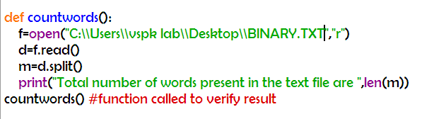



Q10) Replace a Word from the File

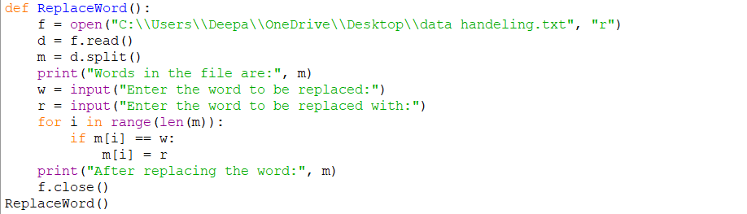

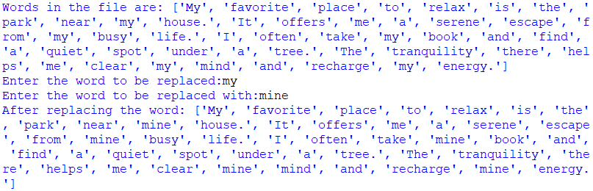

11)Write a function result() to open a file "Student.txt" in write mode. Store names of the five students along with the marks in English, Maths and Computer Science in this file.

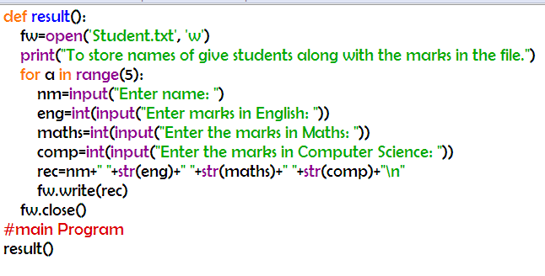

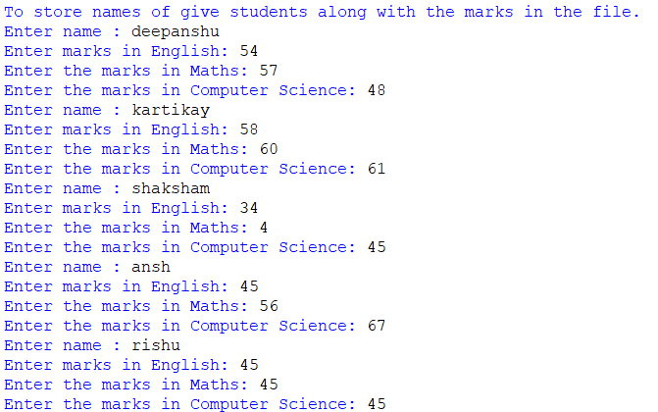

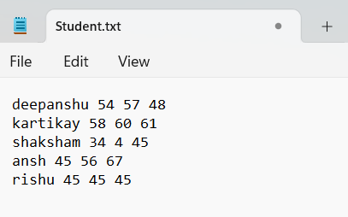

Q12. Write a function Multiple() in Python to create a text file 'Note.txt' to write few lines into it. If you don't want more lines then enter 0(zero) to quit the function

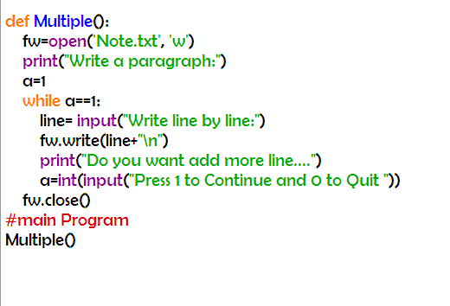

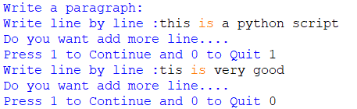

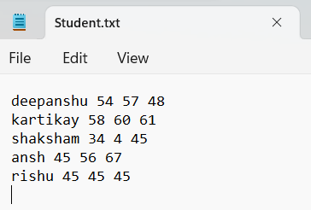

Q13)Write a program that reads characters from the keyboard one by one. All lower case characters get stored inside the file LOWER, all upper case characters get stored inside the file UPPER and all other characters get stored inside file OTHERS.

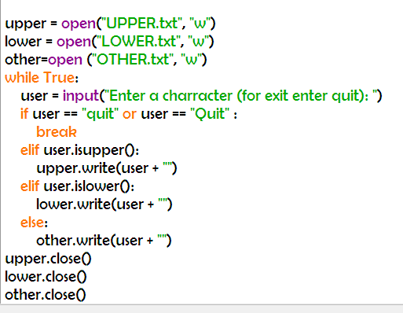 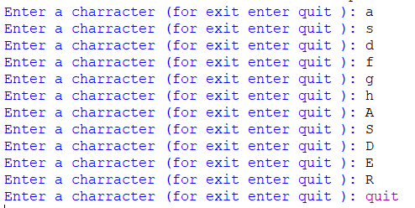

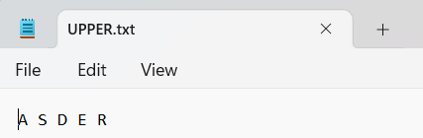 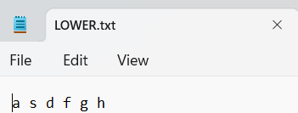

Q14. Write a program that copies a text file "notes.txt" onto "target.txt" barring the lines starting with "@" sign.

